PROJECT DOCUMENTATION

Script - Controlled ACL -- Restrict Record Access Based on Field Value
Team details :
- Team ID : SWTID-2026-7124
- Team Leader :
- Swetha S - 202400044@sigc.edu

- Team Members :
- Rithika Shree V- 202400673@sigc.edu
- Rooba P- 202400519@sigc.edu
- Swathy P- 202400822@sigc.edu

- ABSTRACT:
This project demonstrates how Script-Controlled Access Control Lists (ACLs) can be used in ServiceNow to restrict access to records based on user roles and field values. A custom table named “Institution Details” is created with student-related fields such as Student Roll Number, Student Name, Faculty Name, Branch, Email, Phone Number, and Description.
Different roles (bb1, bb2, bb3, and bb4) are created and assigned to users. A READ ACL uses the Branch field and a script to allow EEE-related access, while CREATE, WRITE, and DELETE ACLs control the other record operations. Administrators retain full access. The project shows how role-based and script-based security can protect records from unauthorized viewing, creation, modification, and deletion.

- INTRODUCTION:
Access control is an important part of application security. In a platform such as ServiceNow, different users may need different levels of access to records. ACLs are used to decide whether a user can read, create, update, or delete a record.
In this project, a script-controlled ACL is implemented for the custom table “Institution Details”. The main scenario is that users associated with the EEE branch are allowed to access EEE branch records, while administrators have full access.

- PROBLEM STATEMENT:
The project solves this problem by using ServiceNow ACLs together with a script that checks the user's role and controls access to records.

A system may contain records belonging to different branches such as ECE, EEE, and CSE. Allowing every user to view or modify all records can lead to unauthorized access. Therefore, a security mechanism is required to control record access based on user roles and field values.

- OBJECTIVES:
- Create a test user and custom roles in ServiceNow.
- Create a custom table for institution/student details.
- Create records with different branch values such as ECE, EEE, and CSE.
- Implement a script-controlled READ ACL.
- Implement CREATE, WRITE, and DELETE ACLs using separate roles.
- Allow administrators to retain full access.
- Verify access behaviour for users with different role combinations.
- Understand how ServiceNow protects sensitive records at record level.

- PROJECT DESCRIPTION:
Platform | ServiceNow
Custom Table Label | Institution Details
Custom Table Name | u_institution_details
Main Security Concept | Script-Controlled ACL
Custom Roles | bb1, bb2, bb3, bb4
Special Access | Administrator
Main Branch Condition | EEE
The project is a ServiceNow security implementation in which access to the custom table “u_institution_details” is controlled through ACLs. The READ operation uses role and branch-related conditions, while CREATE, WRITE, and DELETE operations require additional roles.

- SYSTEM REQUIREMENTS:
Software / Platform:
- ServiceNow instance with administrator access.
- Web browser for accessing the ServiceNow instance.
- Security_admin role for creating/modifying ACL records.

User and Role Requirements:
- Test user: EEE User
- Test user email: eeeuser@gmail.com
- Custom roles: bb1, bb2, bb3, bb4
- Administrator access for configuration and verification.

- METHODOLOGY:
The project is implemented through the following sequence:
- Create a test user.
- Create custom roles and assign them to the test user.
- Create the Institution Details custom table.
- Add the required student/institution fields.
- Create records with different branch values.
- Create and configure the READ ACL.
- Create and configure the CREATE ACL.
- Create and configure the WRITE ACL.
- Create and configure the DELETE ACL.
- Impersonate users and verify the access behaviour.

Operation | Required Role | Expected Access
Read | bb1 | EEE branch records
Create | bb2 | Create records
Write | bb3 | Edit records
Delete | bb4 | Delete records
All operations | admin | Full access
- Access Model:

User Creation:
- Log in to the ServiceNow instance with admin access.
- Navigate to User Administration → Users.
- Click New.
- Create the test user with User ID: EEE User.
- First name: EEE.
- Last name: User.
- Email: eeeuser@gmail.com.
- Save the record.
Role Creation:
- Navigate to User Administration → Roles.
- Click New.
- Enter role name as bb1 and provide a brief description.
- Submit the role.
- Create the additional roles bb2, bb3, and bb4 using the same procedure.
- Assign all required roles to the EEE User for testing.

- Custom Table Creation:
Label | Institution Details
Name | u_institution_details
Extends for | false
A custom table named “Institution Details” is created to store student-related information.

Fields:
Field | Type | Purpose
Student Roll Number | Auto Number | Automatically generated roll number
Student Name | Reference - User | Reference to a user
Faculty Name | Reference - User | Reference to a user
Branch | Choice | ECE, EEE, CSE
Email | String | Student email
Phone Number | String | Contact number
Description | Multi String | Additional details

- READ ACL IMPLEMENTATION:
The READ ACL controls whether a user can view records in the u_institution_details table.

- Navigate to System Security → Access Control (ACL).
- Elevate the Security_admin role.
- Click New to create a new ACL.
- Type: record.
- Operation: read.
- Name: u_institution_details.
- Active: true.
- Set Advanced: true.
- In the Requires role related list, add bb1.
- Add the data condition: Branch is EEE.
- Enter the following script.

(function () {
// Allow admin users full access
if (gs.hasRole('admin')) {
return true;
}
// Allow only EEE branch users to see EEE records
if (gs.hasRole('bb1')){
return true;
}
// Deny access for all others
return false;
})();
The ACL is then submitted and saved. During verification, a user with the bb1 role can view the EEE branch records, while a user without the required role cannot view the records. An administrator can view all records.

- CREATE ACL IMPLEMENTATION:
- Click New to create a new ACL.
- Type: record.
- Operation: create.
- Name: u_institution_details.
- Active: true.
- In the Requires role related list, add bb2.
- No data condition is required.
- Save the ACL record.

- WRITE ACL IMPLEMENTATION:
- Click New to create a new ACL for the Write operation.
- Type: record.
- Operation: Write.
- Name: u_institution_details.
- Active: true.
- In the Requires role related list, add bb3.
- No data condition is required.
- Save the ACL record.

DELETE ACL IMPLEMENTATION:
- Click New to create a new ACL for the Delete operation.
- Type: record.
- Operation: Delete.
- Name: u_institution_details.
- Active: true.
- In the Requires role related list, add bb4.
- No data condition is required.
- Save the ACL record.

- VERIFICATION AND TEST RESULTS:
The configured ACLs are verified by impersonating the EEE user and administrator and opening the Student Records / Institution Details list.
- Impersonate the EEE user and open the Student Records list.
- Use the table name u_institution_details.list in the All menu.
- Impersonate the administrator and open the same list.
- Compare the available records and operations.

User / Role | Read | Create / Edit | Delete
User with bb1 | EEE records | Depends on additional roles | Depends on additional role
User without required role | Denied | Denied | Denied
bb1 + bb2 + bb3 | EEE records | Allowed | Depends on bb4
bb1 + bb2 + bb3 + bb4 | EEE records | Allowed | Allowed
Administrator | All records | Full access | Full access

ADVANTAGES:
- Provides record-level security in ServiceNow.
- Restricts access according to user roles.
- Can use field values such as Branch to control access.
- Separates permissions for Read, Create, Write, and Delete operations.
- Administrators can retain full access.
- Helps prevent unauthorized viewing and modification of records.

LIMITATIONS:
- The implementation is demonstrated on the custom Institution Details table.
- The example mainly focuses on EEE branch access for the READ scenario.
- Correct role assignment is required for the ACL behaviour to work as expected.
- Testing must be performed carefully using appropriate user impersonation.

- FUTURE ENHANCEMENT:
- Extend the field-based access model to multiple branches with different role rules.
- Add more granular conditions based on department, faculty, or other record fields.
- Create more detailed test cases for different combinations of roles.
- Add automated testing and monitoring for ACL behaviour.
- Integrate the access-control model with larger ServiceNow applications.

OUTPUT:
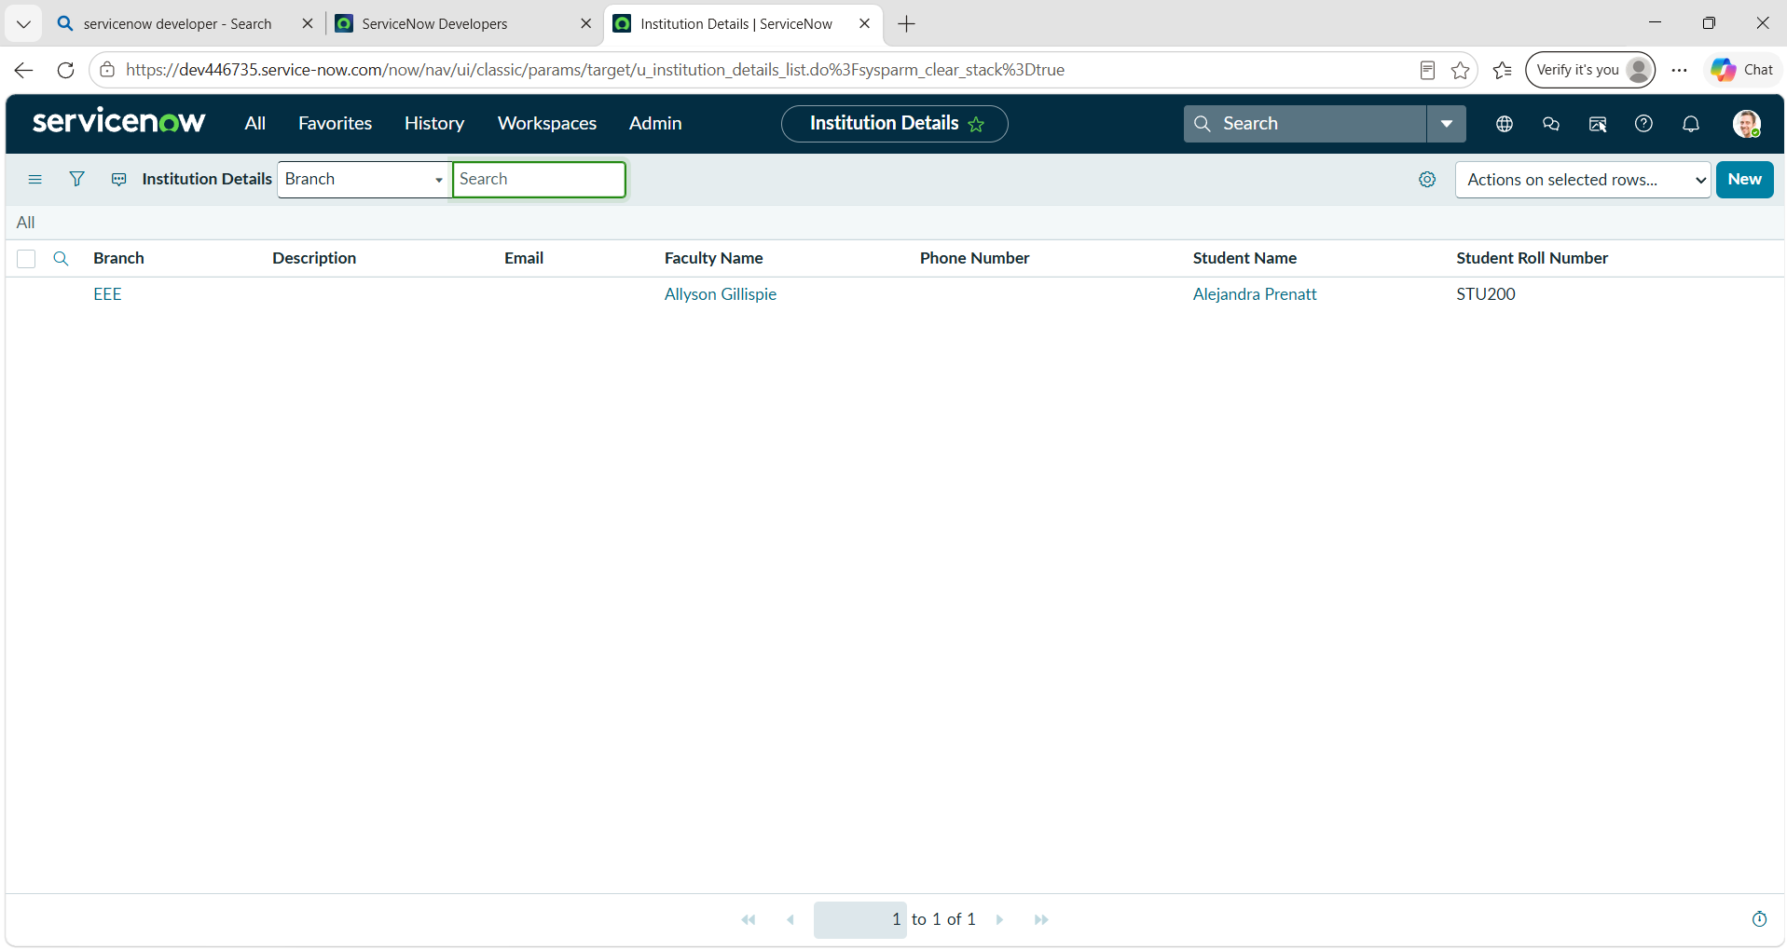

- CONCLUSION:
The project successfully demonstrates the use of Script-Controlled Access Control Lists in ServiceNow. Users and roles are created, a custom Institution Details table is configured, and separate ACLs are implemented for READ, CREATE, WRITE, and DELETE operations.
The implementation shows how user roles and record information can be used together to control access. The final verification demonstrates that users receive only the permissions associated with their roles, while administrators retain full access. Overall, the project provides practical understanding of record-level security and ACL-based access control in ServiceNow.

REFERENCE:
Demo Video Link: https://drive.google.com/file/d/1ObaxcBmqPWaYrYB7tps5NclnF0ZLn5X6/view?usp=sharing

